Step 1: Plug in the Ethernet cord.

Step 2: Right click the Network icon in the bottom right corner. 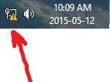 Press **Open Network and Sharing Centre**.

Step 3: Press on **Ethernet** in this screen:

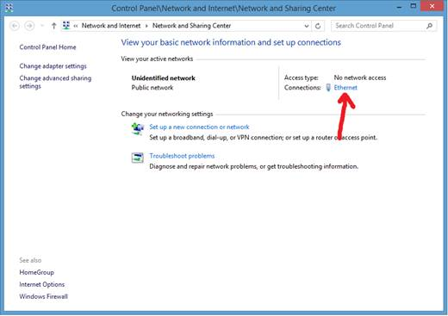

Step 4: **Properties**

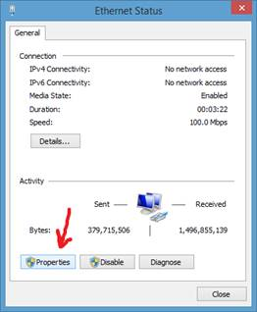

Step 5: Chose the **IPv4** option and press **Properties**.

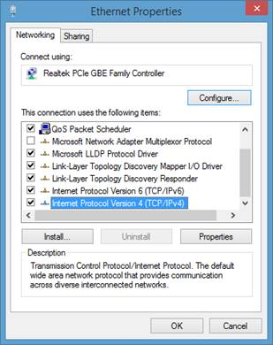

Step 6: Type in the following settings and press OK:

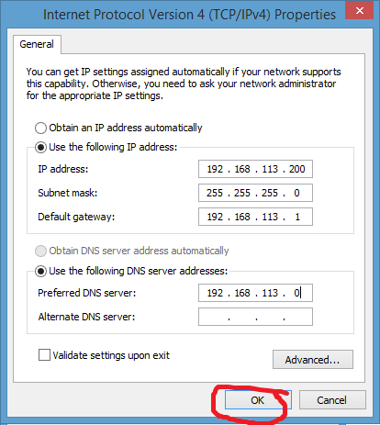

Step 7: Open up File Explorer (or any folder) and in the address bar, type in ‘*\\192.168.113.201*’ and hit Enter.

Once you are done, get back to the screen in Step 6 and press **Obtain an IP address automatically** and **Obtain DNS server address automatically** to revert to old settings.